08th January 2018

**YOKOHAMA Builds Indoor Facility to Test Winter Tyres at Asahikawa Tyre Test Center in Hokkaido**

YOKOHAMA announced on 30th January that it has built an indoor facility to test the performance of winter tyres on ice. Located at YOKOHAMA’s Tire Test Center of Hokkaido (TTCH) in Asahikawa City, the new facility began testing tyres on 5th January. The 30th January ceremony commemorating the facility’s opening was attended by special guests Masahito Nishikawa, the mayor of Asahikawa, and Hitoshi Yoneshima, CEO of Kishida Gumi Co., Ltd., the company that designed and built the facility. Representatives from Yokohama Rubber included Tadanobu Nagumo (Chairman and Representative Member of the Board) and Osamu Mikami (Member of the Board and Senior Managing Officer, President of Tyre Business) and Masaki Noro (Member of the Board and Managing Officer, Chief Tyre Technical Officer).   
  
The TTCH was opened in December 2015 to expand YOKOHAMA’s tyre testing capacity in line with the global expansion of its tyre business, and to introduce more sophisticated evaluation methods. The new indoor facility, featuring an ice track, further enhances TTCH’s testing capabilities. Compared to outdoor test courses, an indoor course is unaffected by such external factors as the weather and outdoor temperatures, and the ice track’s condition can be kept stable. As a result, the accuracy of test data can be improved, facilitating the development of more advanced technologies. The new facility’s size—total floor area of about 2,860 square meters, at 119m x 24m, and an 8.8m high ceiling (at highest point)—makes the indoor facility suitable for testing tyres used on trucks and buses as well as passenger cars.   
  
YOKOHAMA has positioned its winter tyres as its most important product for driving global growth and therefore aims to manufacture and supply the world’s best-performing winter tyres. In addition to TTCH, YOKOHAMA has a winter tyre test course in Sweden – the Yokohama Test Center of Sweden (YTCS). TTCH tests YOKOHAMA’s full lineup of winter tyres sold around the world, while YTCS conducts additional tests to confirm the suitability and performance of YOKOHAMA tyres to be sold in continental Europe, Russia and Northern Europe. Together, these two test facilities contribute to YOKOHAMA’s development of winter tyres most suitable to the winter road conditions in the country or region of use.

###### Profile of new indoor test facility

Building size: 119 meters long, 24 meters wide, 8.8 meters high (at highest point)   
Total floor area: 2,859.6 square meters   
Construction: Steel-framed single-story structure  
Start of operations: January 5, 2018

###### Profile of Yokohama Rubber’s Hokkaido test facility

Name: Tire Test Center of Hokkaido (TTCH)   
Start of operations: December 2015  
Location: 500 Kamiubun, Kamui-cho, Asahikawa City, Hokkaido Prefecture  
Site area: 906,462 square meters

Tested products: Winter tyres used on passenger cars, trucks and buses (also tests summer tyres from spring to autumn)  
Test courses: 1km-long straight snow track able conduct tests with cars running at speeds above 100kph, flat ice track, snow and ice hill track, snow and ice circles, and a handling track

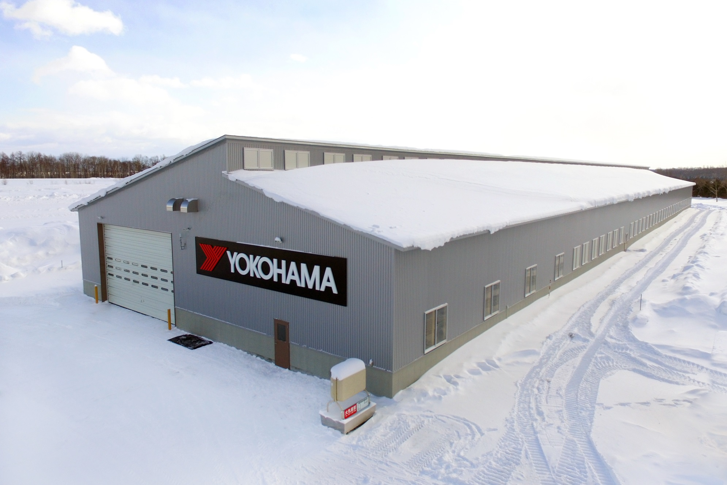

*Exterior view of new indoor test facility*

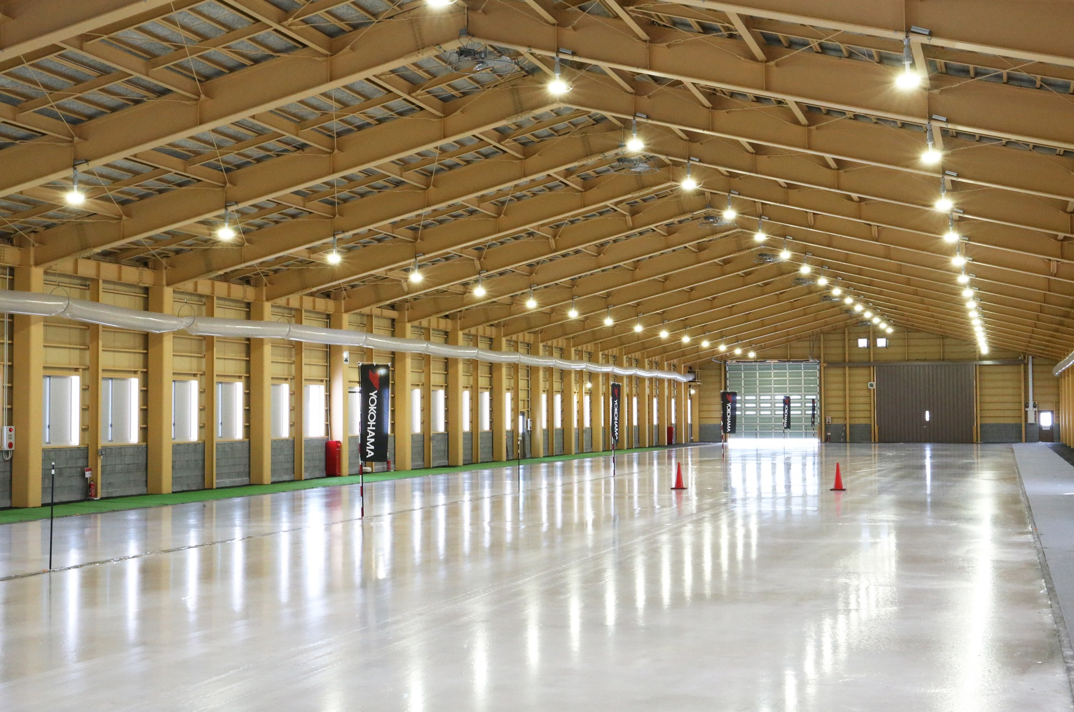

*Ice track of interior*